Name_______________ 1/28-29/15
Physics/ _____Block UPC/ House_______________
The Great Egg Drop
Your mission:
Today your goal is to design a container that will protect an egg, when dropped from extreme heights.
You must be able to explain how and why each component of your container contributes to your strategy of reducing impact force

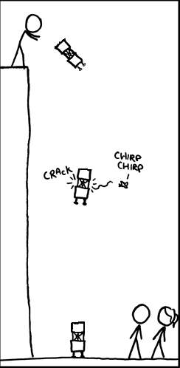
The purpose:
Be able to explain and apply the 3 basic strategies for reducing the impact force of a moving object.

The parameters:
You will have 15 minutes to build a container with your group
You will drop your egg from a height of 3 meters, and if successful, from out the window.
You can use any materials you receive, but will not receive any new materials, or a replacement egg
It should take less than 30 seconds to remove your egg, after the drop, and it must be removed completely to check it
You should design your container according to a strategy which you will outline below

The materials:
1 bag 12 cotton balls
5 paper cups 10 cotton swabs
10 drinking straws 15 stirring straws
100cm masking tape 5 rubber bands (upon request)

Initial Strategy: As you consider the materials, recall that impact force, or any force, is the product of mass*acceleration. Write an initial strategy that considers as many methods as possible to reduce impact force:
____________________________________________________________________________________________________________________________________
____________________________________________________________________________________________________________________________________
___________________________________________________________________________________________________________________________________.

Pre-drop analysis:
Sketch your container in the space, below, and label it. An example is given, which used slightly different materials
Sketch of container

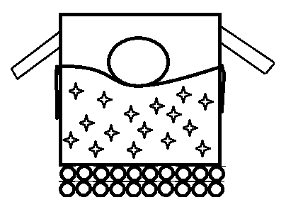

Describe the container. For every part of your container, you need to be able to say
1. What you did to your container
2. How it figures into your strategy

____________________________________________________________________________________________________________________________________
____________________________________________________________________________________________________________________________________
____________________________________________________________________________________________________________________________________
____________________________________________________________________________________________________________________________________
Post-drop reflection:
Did your container actually follow the strategy you intended it to (did it fall the way you planned?). Explain:
____________________________________________________________________________________________________________________________________
____________________________________________________________________________________________________________________________________

Restate your strategy.
____________________________________________________________________________________________________________________________________
____________________________________________________________________________________________________________________________________

Describe if it was successful, and why/why not?
____________________________________________________________________________________________________________________________________
____________________________________________________________________________________________________________________________________
___________________________________________________________________________________________________________________________________.

What strategies did you see from other groups? Were any successful, and if so, why?
____________________________________________________________________________________________________________________________________
____________________________________________________________________________________________________________________________________
___________________________________________________________________________________________________________________________________.

Even if your egg drop container was successful, what would you do differently next time?
____________________________________________________________________________________________________________________________________
____________________________________________________________________________________________________________________________________
___________________________________________________________________________________________________________________________________.

Exit Slip Questions: (completed after discussion/lesson)
The picture below shows a man in Varanasi, India, resting on a bed of nails. Which principle about impact force allows him to do this without getting hurt, and why?

Hitting a homerun in baseball is difficult, because it requires a lot of force (why A-Rod took steroids). Most homeruns are hit off of fastballs. Which principle about impact force says that this makes sense, and why?

After Jayden Lucas tries to dunk a basketball, he bends his knees as he returns to the ground. Which principle about impact force says that he should bend his knees instead of just landing straight-legged, and why?

