Name_______________ 2/3/15
Physics/ _____Block UPC/ House____________
Calculating Gravitational Acceleration Procedures

Before you enter the lab, there are a few things to do to be prepared:
- Describe how to calibrate your spring scale if you get one that is off.

- Give the readings for each of the following spring scales
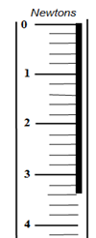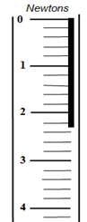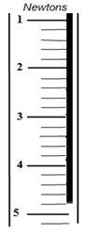

Lab procedures. Read the following lab procedures and answer the following questions
- In your notebook, draw a 4 column table for the object, mass, force, and acceleration
- Check your spring scale to ensure that it is properly calibrated
- Hang an object from the spring scale. Once it has settled, record the gravitational Force (weight) of the object in Newtons. Have 2 partners verify the weight in N.
- Place the same object on the digital balance and record the object’s mass in kilograms
- Repeat steps 2-4 for 5 total objects of varying mass
- Calculate the acceleration of each object using the formula F=ma
- In your notebook, plot the graph of mass vs gravitational Force
- In your notebook, plot the graph of mass vs acceleration
What data do you need to collect for each object? What data do you need to calculate for each object?

After measuring each object, what do you need to check before using another object?

How many people need to confirm the gravitational Force (weight) of each object?

What do you do once you have finished calculating the accelerations for all 5 objects?

Post Lab Questions:
- What trend/relationship are you finding between mass and gravitational Force? Why do you think this is?

- What trend/relationship are you finding between mass and acceleration? Why do you think this is?

- Define mass (can use notes):

- Define weight (can use notes):

- Explain the difference/how they are related:

- A car has a mass of 1,500 kg. What is its weight?

- What is the weight of a 5-kg rock?

- What is the gravitational acceleration of a 3kg textbook?

- What is the mass of a 500-N bookshelf?

- What is the gravitational acceleration of a 78N box?

