DO NOW: VOCAB QUIZ #7

Directions: Fill in the blanks with the best choice from our weekly vocab list. No other items should be on your desk..

__________________________________ A quantity that measures the rate of change of distance traveled in one
unit of time (i.e. one second)

__________________________________ A downward force caused by the pull of Earth onto another an object

__________________________________ The force that balances against an object’s weight on a surface

__________________________________ The force that occurs when two objects touch that makes them slow down
and stop

__________________________________ A measure that is a combination the total force that acts on a given object

__________________________________ A type of quantity in which both magnitude and direction are measured

__________________________________ A quantity that measures the change in position of an object

__________________________________ A steady state in which all the forces acting on an object are balanced, such
that ƩF=0N

__________________________________ A measure of how much an object resists changes in motion

__________________________________ How much a given quantity changes in one second of time (or one unit of
another quantity)

EXPLORE: FORCE PAIRS

FRAMING THE INVESTIGATION

Guided Practice: Complete the following pre-investigation questions to prepare to complete the activity

CORE QUESTION:____________________________________________________________________________________________________

________________________________________________________________________________________________________________________

Factors that may affect force between two objects:

- ________________________________________________

- ________________________________________________

- ________________________________________________

- ________________________________________________

- ________________________________________________

- ________________________________________________

This question is completely different from our previous investigations/practice because:__________________

________________________________________________________________________________________________________________________

________________________________________________________________________________________________________________________

EXPLORE: FORCE PAIRS

ROUND 1 Complete the table below based on the teacher’s instructions, while each scenario is modeled at the front of the room
Scenario 1 Description: | Scenario 1 Predict which tube will bend more | Scenario 1 Result

Scenario 2 Description: | Scenario 2 Predict which tube will bend more | Scenario 2 Result

Scenario 3 Description: | Scenario 3 Predict which tube will bend more | Scenario 3 Result

Scenario 4 Description: | Scenario 4 Predict which tube will bend more | Scenario 4 Result

What relationship do you think exists between car speed, and force between the cars_______________________
________________________________________________________________________________________________________________________

What relationship do you think exists between heaviness, and force between the cars______________________
________________________________________________________________________________________________________________________
ROUND 2 Complete the table below based on the teacher’s instructions, while each scenario is modeled at the front of the room
How to read a spring scale:
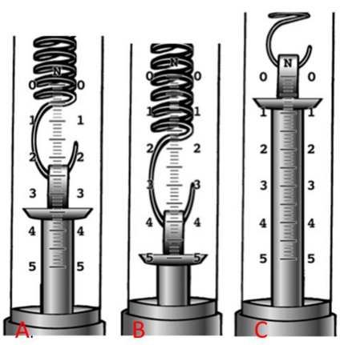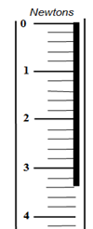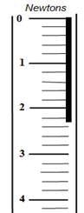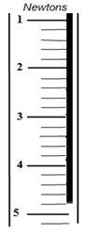

A: ___________ B:___________ C:___________ D:__________ E:__________ F:__________

Scenario 1 Description:  Both partners hook together the spring scales. Partner A pulls to 5 N, and partner B reads her spring scale. | Scenario 1 Predict which spring scale will read more | Scenario 1 Result

Scenario 2 Description:  Hook scales together, set directly on the desk. Partner B pulls to 5 N while partner A holds his spring scale steady, | Scenario 2 Predict which spring scale will read more | Scenario 2 Result

Scenario 3 Description:  Both partners push their scales against each other. Partner B pushes to 5 N, and partner A reads her spring scale. | Scenario 3 Predict which spring scale will read more | Scenario 3 Result

Scenario 4 Description:  Both partners push their scales against each other, directly on the desk. Partner A pushes to 5 N, and partner B reads his scale. | Scenario 4 Predict which spring scale will read more | Scenario 4 Result
Force pairs theory 3: _______________________________________________________________________________________________
________________________________________________________________________________________________________________________

ROUND 3 Complete the table below based on the teacher’s instructions, while each scenario is modeled at the front of the room
Scenario 1 Description:  Heavy car and light car hit at same speed | Scenario 1 Prediction | Scenario 1 Result

Scenario 2 Description:  Heavy car hits light car while stationary | Scenario 2 Prediction | Scenario 2 Result

Scenario 3 Description:  Light car hits heavy car while stationary | Scenario 3 Prediction | Scenario 3 Result

Scenario 4 Description: | Scenario 4 Prediction | Scenario 4 Result

Force pairs theory 4: ________________________________________________ _______________________________________________
________________________________________________________________________________________________________________________

Statement about the magnitude of both forces in any interaction:______________________________________________

________________________________________________________________________________________________________________________

Statement about the direction of both forces in any interaction:________________________________________________

________________________________________________________________________________________________________________________

Write a final statement comparing the force between two objects in any interaction: FORCES ALWAYS

COME IN PAIRS________________________________________________________________________________________

________________________________________________________________________________________________________________________

PREPWORK: N/A

Directions: Draw a picture of a t-rex wearing a dress and sunhat

