ELECTRICITY AND MAGNETISM

DO NOW: ELECTROSCOPE QUICK REVIEW
DIRECTIONS: Test your preparation for the Re-test objective on electroscopes

What keyword tells you there will be + and – ions in your electroscope?_______________________________________

What keyword tells you there will only + or – ions in your electroscope?_______________________________________

A student looks at the electroscope to the right and says “positive ions moved up, and negative ions moved down.”
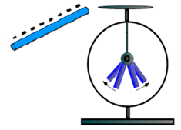
Explain why they are wrong,____________________________________________________

Explain what really happened___________________________________________________
____________________________________________________________________________________
____________________________________________________________________________________

A student looks at the electroscope to the right and says “the leaves are now attracting.”
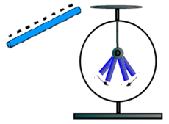
Explain why they are wrong,____________________________________________________

Explain what really happened___________________________________________________
____________________________________________________________________________________
____________________________________________________________________________________

Action Step 1:_________________________________________________________________________________________________________

Action Step 2:_________________________________________________________________________________________________________

RETEST OBJECTIVE: ELECTROSCOPES
- Various charges are induced on a neutral electroscope. Which statement below describes how the foil leaves will react?
  - Positive charges will make the leaves repel, negative charges will make the
leaves attract
  - Negative charges will make the leaves repel, positive charges will make the
leaves attract
  - Any induced charge will make leaves repel
  - Any induced charge will make leaves attract

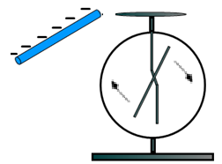
In this electroscope, the diagonal wire is able to spin, and may do so when different charges are applied. The curved wire is fixed, and will not move.
- A negatively charged rod is brought near a neutral, metal electroscope. What is the charge on the wires near the bottom, which causes them to repel?

- Positive
- Negative
- It stays neutral
- It depends on the type of metal

The drawing below depicts a positive rod being brought near a charged electroscope.
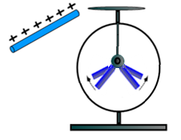
- As a result of the rod being brought near the electroscope’s foil leaves move even farther apart from each other, as shown. What was the charge on the electroscope before the positive rod was brought near the electroscope? In your answer:
  - Identify which sub-atomic particles will move in the electroscope
  - Describe the direction of the particles’ motion
  - Explain why the particles move that direction
  - State the original charge on the electroscope
  - Describe the change in the net charge at the bottom of the electroscope
  - Explain why the change in net charge causes the leaves to move even farther apart from each another.

________________________________________________________________________________________________________________________
________________________________________________________________________________________________________________________
________________________________________________________________________________________________________________________
________________________________________________________________________________________________________________________
________________________________________________________________________________________________________________________
________________________________________________________________________________________________________________________
________________________________________________________________________________________________________________________

REVIEW: ELECTRICITY AND MAGNETISM
Partner Practice: Discuss the following questions with your seat partner, then be prepared to share out and write core ideas in the space below

What is the key difference between electricity and magnetism?: ________________________________________________
_________________________________________________________________________________________________________________________
_________________________________________________________________________________________________________________________

What are some of the key similarities between electricity and magnetism?: ___________________________________
_________________________________________________________________________________________________________________________
_________________________________________________________________________________________________________________________

Prelab Questions
- Define/explain the term “electrostatic charge,”:

- Define/explain the term “electrical current,”:

- Electrical current is similar to electrostatic charge because:

- Electrical current is different from electrostatic charge because:

Today’s Objective:____________________________________________________________________________________________________

_________________________________________________________________________________________________________________________

_________________________________________________________________________________________________________________________

Task One: Determine how electrical charges affect magnetic fields

Materials: One C battery Compass
Light bulb with wire Scotch Tape

Procedures:
- Charge a piece of scotch tape by pulling it quickly off the table and test it. Place it close to the compass and see if the compass moves.
- Connect your battery to your light bulb to ensure you have a circuit, then disconnect them and leave as an open circuit.
- Test the closed circuit with the battery, wire, and light bulb all together as a circuit. Place them close to the compass and see if the compass moves.
- Test the open circuit with the battery, wire, and light bulb all together but disconnected. Place them close to the compass and see if the compass moves.

In your own words, explain what we will actually do to “determine how electrical charges affect magnetic fields”

Data Table:
Object | Effect on Light Bulb: | Effect on Compass: | Movement direction
Ball point pen (uncharged object) | --X--
Charged Scotch tape | --X--
1 C battery- Open circuit
1 C battery- closed circuit

- In which situations above was there an electrical current? Cite your evidence:

- In which situations above did the compass needle move?

- Was there any specific direction attached to the way the compass needle moved?

- Describe the relationship between how electricity can affect a magnet, that you discovered in this demo. Be specific about electrical current vs electrostatic charge.
_____________________________________________________
_________________________________________________________________________________________________________________________
_________________________________________________________________________________________________________________________

Task Two: Determine how magnetic fields affect electrical currents:
Materials: Ammeter with alligator clips Bar magnet
Transparency tube Copper wire coil
Procedures:
- Check that your ammeter is calibrated to 0. If it is not, note this in your ammeter readings.
- Hold the transparency tube in one hand, and the bar magnet in the other.
- Place the bar magnet inside the transparency tube and complete each action in the table below

What types of tasks will we perform in order to “determine how magnetic fields affect electrical currents”

Data table:
Action: | Is current induced? | Max Ammeter Reading
Hold North pole constant inside metal coil
Drop North pole through near end of coil (moving slowly)
Drop North pole through far end of coil (moving quickly)
Ball point pen (uncharged object), constant or moving
Hold South pole constant inside metal coil
Drop South pole through near end of coil (moving slowly)
Drop South pole through far end of coil (moving quickly)

- Which types of situations were able to induce an electrical current in the wire?

- How does the increasing the magnet’s speed affect the amount of current produced?

- Does the magnetic pole affect the direction of the current? Explain.

- Describe the relationship between magnetism and electricity that you discovered in this activity. Be specific about what the magnet had to do to create a current.
________________________________________
_________________________________________________________________________________________________________________________
_________________________________________________________________________________________________________________________

CONCEPT SUMMARY:

Task One: Determine how electrical charges affect magnetic fields
Describe the relationship between electricity and magnetism that you discovered in this demo. Be specific about electrical current vs electrostatic charge

CORE IDEA 1: _________________________________________________________________________________________________________
_________________________________________________________________________________________________________________________
Task Two: Determine how magnetic fields affect electrical currents:
Describe the relationship between magnetism and electricity that you discovered in this activity. Be specific about what the magnet had to do to create a current.

CORE IDEA 2: _________________________________________________________________________________________________________
_________________________________________________________________________________________________________________________
CORE IDEA 3: _________________________________________________________________________________________________________
_________________________________________________________________________________________________________________________

Concept summary: _________________________________________________________________________________________________
_________________________________________________________________________________________________________________________
_________________________________________________________________________________________________________________________

Concept analogy: _____________________________________________________________________________________________________
_________________________________________________________________________________________________________________________
_________________________________________________________________________________________________________________________

PRACTICE: ELECTRICITY AND MAGNETISM
Independent Practice Round 1: Silently and independently complete the following problems. Use your notes and the sample problems from guided practice. Be ready to share and explain your answers.

- The two magnets below are held above a metal circuit. One is simply held, the other is dropped through.
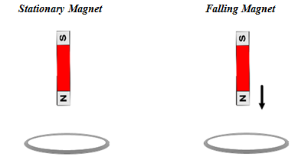
Would there be a difference in the current induced if the magnet were dropped through the coil instead of just held near it. Which situation(s) would produce a current?

_________________________________________________________________________________________________________________________
_________________________________________________________________________________________________________________________
_________________________________________________________________________________________________________________________

- Two students are debating the compass and circuit from task one.

Student A: The current creates a magnetic field, which moves the compass
Student B: The current produces an electromagnetic field, which moves the compass

Which student do you agree with, and why?
_________________________________________________________________________________________________________________________
_________________________________________________________________________________________________________________________
_________________________________________________________________________________________________________________________

Independent Practice Round 2: Silently and independently complete the following problems. Use your notes and the sample problems from guided practice.

- Two magnets are pushed through a metal loop. Magnet A is pushed quickly while Magnet B is pushed slowly, as shown in the diagram below:
Magnet A Magnet B
Circle the circuit that will be most likely to be able to turn on a lightbulb, and explain your answer in terms of electrical current:

_________________________________________________________________________________________________________________________
_________________________________________________________________________________________________________________________
- Determine whether each of the following situations would produce a magnetic field:

  - A stationary neutral particle Yes -OR- No
  - A neutral particle moving in a straight line Yes -OR- No
  - A stationary charged particle Yes -OR- No
  - A moving charged particle Yes -OR- No

- True -OR- False When there is a current, it produces an electromagnetic field.

Explain:
_________________________________________________________________________________________________________________________
_________________________________________________________________________________________________________________________

- The magnet below is pushed downward through a metal wire loop.
Would there be a difference in the current induced if the magnet were dropped through the coil South pole first rather than North pole first? Explain your reasoning below.

_________________________________________________________________________________________________________________________
_________________________________________________________________________________________________________________________

EXIT SLIP: ELECTRICITY AND MAGNETISM

- The north end of a magnet moves through a wire loop while the south pole of a magnet rests stationary near a metal loop as shown in the images below.
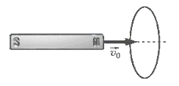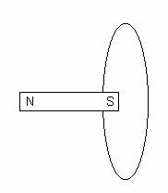
Which of these two will induce an electric current and why? Answer and explain:

_________________________________________________________________________________________________________________________
_________________________________________________________________________________________________________________________

The north pole of a magnet is dropped through a metal loop as shown below.
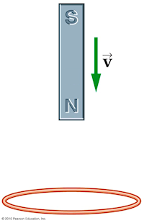
Would there be a difference in the current produced if the south end were dropped instead of the north end?

Answer and explain:

_________________________________________________________________________________________________________________________
_________________________________________________________________________________________________________________________

- Circle any/all which of the following would produce a magnetic field:

A moving neutral particle A stationary neutral particle A moving charged particle

A wire with a current flowing A stationary charged particle A wire without current flowing

DIRECTIONS: The problem below exactly models what you will see on Friday’s quiz. A good score on parts A and B will erase a low grade on the last quiz. Try this without notes, but if needed, use a rubric provided from old notes pages

- A 1200 kg car has velocity 10m/s when it collides with a 2400kg truck, which has velocity -8m/s. The two carts bounce apart after the collision. After they collide, the car has a new velocity of -14 m/s.

  - Draw a motion diagram of the situation

  - What is the final velocity of the truck?

  - What is the total force acting on the truck, if the collision lasts .2 seconds?

PREPWORK 12.04: ELECTRICITY AND MAGNETISM

- Two magnets are dropped one at a time through a metal coil. One is dropped with the north pole first and one is dropped with the south pole first. Describe the magnitude (size) and direction (positive/negative) of the current in each loop.
- The magnitude and direction of the current will be the same both times.
- The magnitude will be the same both times but the direction will change
- The magnitude will change but the direction will be the same both times
- Both the magnitude and the direction of the current will change

Explain citing evidence from the lab:
_________________________________________________________________________________________________________________________
_________________________________________________________________________________________________________________________
- The north end of a magnet hangs motionless above a metal loop
Current -OR- No Current
Explain citing evidence from the lab:
_________________________________________________________________________________________________________________________
_________________________________________________________________________________________________________________________
Word bank: Compass Current Magnet Circuit Electrostatics

- ______________________________ is when charges(electrons) are at rest
- Electrical current is when charges(electrons) move in a _____________________________
- Moving electrons (_________________) can move a ___________________________
- A compass is a mini __________________________
- Use your answers and the vocabulary above to write an explanation of how electricity can be used to make a compass move.
_________________________________________________________________________________________________________________________
_________________________________________________________________________________________________________________________
- Which statement is more accurate?
  - A magnet can clearly affect the direction of an electrical current.
  - An electrical current can clearly affect the direction of a compass (magnet)
Explain citing evidence from the lab:

_________________________________________________________________________________________________________________________
_________________________________________________________________________________________________________________________

VOCAB QUIZ PREP
DIRECTIONS: 10 of the following vocab words will appear on Friday’s quiz

__________________________ Particle inside the nucleus of an atom, has no charge and mass of 1 amu
__________________________ A force exerted between two charges which either attracts or repels
__________________________ Particle moving around outside the nucleus of an atom, has a negative charge and
essentially no mass (.00055 amu)
__________________________ The positively charged center of an atom, consisting of protons and neutrons

__________________________ An atom that has lost electrons and has a net positive charge

__________________________ The smallest particle of an element that can be identified with that element

__________________________ Particle inside the nucleus of an atom, has a positive charge and mass of 1 amu

__________________________ An atom that has gained electrons and has a net negative charge

__________________________ The sum of the protons and neutrons in an atom

__________________________ A physical property of subatomic particles which causes them to attract or repel

__________________________ The positively charged center of an atom, consisting of protons and neutrons

__________________________ An atom that has lost electrons and has a net positive charge

__________________________ A substance through which electrons can move easily

__________________________ A substance through which electrons cannot move easily

__________________________ A device used to determine if an object has an electrostatic charge

__________________________ The process of creating a charge in an object without touching it

__________________________ A shorthand notation used to write very large or very small numbers

