Electricity flows through wires to light our lamps, run TVs, computers and all other electrical appliances. But where does the electricity come from?
Now, we'll learn how electricity is generated in a power plant. In the next few chapters, we'll learn about the various resources that are used to make the heat to produce electricity.

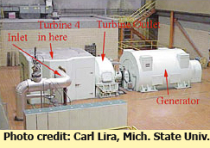
Thermal power plants have big boilers that burn a fuel to make heat. A boiler is like a teapot on a stove. When the water boils, the steam comes through a tiny hole on the top of the spout. The moving steam makes a whistle that tells you the water has boiled. In a power plant, the water is brought to a boil inside the boiler, and the steam is then piped to the turbine through very thick pipes.
In most boilers, wood, coal, oil or natural gas is burned in a firebox to make heat. Running through the fire box and above that hot fire are a series of pipes with water running through them. The heat energy is conducted into the metal pipes, heating the water in the pipes until it boils into steam. Water boils into steam at 212 degrees Fahrenheit or 100 degrees Celsius.
The top picture on the right is of a small power plant located at Michigan State University. The black area to the left of the power plant is coal, the energy source that is burned to heat the water in the boilers of this plant.
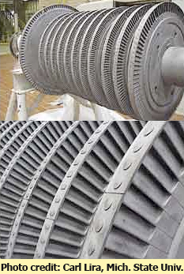
In the second picture to the left, you'll see the turbine and generator at MSU's power plant. The big pipe on the left side is the steam inlet. On the right side of the turbine is where the steam comes out. The steam is fed under high pressure to the turbine. The turbine spins and its shaft is connected to a turbogenerator that changes the mechanical spinning energy into electricity.
The third picture on the right is of the turbine fan before it is placed inside the turbine housing. You can see a close-up of the turbine blades on the fourth picture. The turbine has many hundreds of blades that are turned at an angle like the blades of a fan. When the steam hits the blades they spin the turbine's shaft that is attached to the bottom of the blades.
After the steam goes through the turbine, it usually goes to a cooling tower outside the where the steam cools off. It cools off and becomes water again. When the hot pipes come into contact with cool air, some water vapor in the air is heated and steam is given off above the cooling towers. That's why you see huge white clouds sometimes being given off by the cooling towers. It's not smoke, but is water vapor or steam. This is not the same steam that is used inside the turbine.
The cooled water then goes back into the boiler where it is heated again and the process repeats over and over.
Most power plants in California use cleaner-burning natural gas to produce electricity. Others use oil or coal to heat the water. Nuclear power plants use nuclear energy to heat water to make electricity. Still others, called geothermal power plants, use steam or hot water found naturally below the earth's surface without burning a fuel. We'll learn about those energy sources in the next few chapters.
How the Generator Works
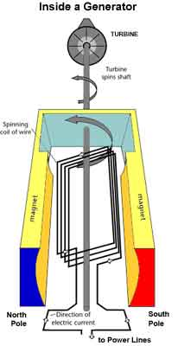
The turbine is attached by a shaft to the turbogenerator. The generator has a long, coiled wire on its shaft surrounded by a giant magnet. You can see the inside of the generator coil with all its wires in the picture on the right.
The shaft that comes out of the turbine is connected to the generator. When the turbine turns, the shaft and rotor is turned. As the shaft inside the generator turns, an electric current is produced in the wire. The electric generator is converting mechanical, moving energy into electrical energy.
The generator is based on the principle of "electromagnetic induction" discovered in 1831 by Michael Faraday, a British scientist. Faraday discovered that if an electric conductor, like a copper wire, is moved through a magnetic field, electric current will flow (or "be induced") in the conductor. So the mechanical energy of the moving wire is converted into the electric energy of the current that flows in the wire.
The electricity produced by the generator then flows through huge transmission wires that link the power plants to our homes, school and businesses. If you want to learn about transmission lines, go to Chapter 7.
All power plants have turbines and generators. Some turbines are turned by wind, some by water, some by steam.

Lab Make-Up Project: Build an Electric Generator

Preliminary information sheet.

Instructions:
You will research and build a small electric generator using household materials and some items found in a local hardware store.

You will submit a short write-up explaining how you built your generator, and applying the concepts to large scale generators found in modern power plants.

The rubric for the paper will be finished and passed out on Thursday if you decide to select this option.
It will be due by Monday 6/15

Materials:
Your materials list will differ depending on which model you select and which types of materials you choose.
Basic materials include:
- Cardboard
- Nail
- Copper Wire
- Magnets
- Light bulb
Total cost for materials should be in the $10-15 range. If you are unable to purchase materials, please see me. I recommend finding your own materials mainly because you get ownership of your work if you do it yourself without outside assistance.

Building a Generator Project

At home writing assignment: Due Monday 6/15/15

After you have finished building your generator complete the following questions on a piece of graph or lined paper

- Describe your process either in step by step form or in paragraph form, using your own words (don’t just copy down internet instructions)
- Address difficulties in building, what steps or ideas were the most challenging?
- Electricity can be a current, or electrostatic. Explain the difference.
- If you add more wire (longer circuit) what happens to the amount of power you generate? Why?
- If you spin the magnet faster, what happens to the amount of power you generate? Why?
- Explain the relationship between electrical force and magnetic force. Specifically, in what circumstances are they interconnected as the electromagnetic force.
- Read the article below and explain how your generator is similar to, and different from generators used in power plants. Consider
  - the basic process of creating an electromagnetic force
  - scope and power generated
  - power sources
  - which pieces are moving

Questions over the weekend? Email twackerman@uncommonprepcharter.org
Or call 650 868 3584

