Butterfly Wings: Using Nature to Learn About Flight

Biomimicry in Butterflies

Introduction
While their wings can be very fragile and easily damaged when handled by humans, butterflies are actually excellent flyers. Some of them—like the Monarch butterfly, which is shown in Figure 1—migrate thousands of miles each year! That's quite an amazing feat for something so small.
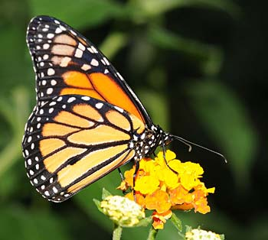
Figure 1. Monarch butterflies may seem delicate and fragile, but they can actually fly thousands of miles each year (Thomas Bresson, 2010).
Most flying animals that you are familiar with from everyday life, like insects and birds, flap their wings, but many also glide. Animals glide by sticking out their wings and coasting, like a paper airplane. Some large birds can glide on air currents for a long time, but butterflies usually only glide for relatively short periods in between flapping their wings. Gliding helps flying animals save energy. Even though butterflies only glide some of the time, this can still help them save a lot of energy over the course of a long migration, like the Monarch's. Watch this slow-motion video to see butterflies alternating between flapping and gliding flight:
Butterflies are such great flyers that a team of researchers at the Harvard University Microrobotics Lab wants to mimic their behavior in order to build a small flying robot that can glide for short periods of time. In order to build a robotic butterfly that can glide, they first had to study the behavior of real butterfly wings, and how air moves around them when butterflies glide. The study of how air moves around wings and other objects is called aerodynamics. The Harvard scientists measured the lift and drag exerted on butterfly wings by the air. Lift is the force that pushes up on the wings of a flying object (whether it is a butterfly, a bird, or an airplane). In order for a flying object to stay in the air, the lift must overcome the object's weight. Drag is what pulls back on flying objects to slow them down, and is caused by air resistance. In order to overcome drag, a flying object must generate thrust to push itself forward. Figure 2 shows lift, drag, weight, and thrust acting on a butterfly.
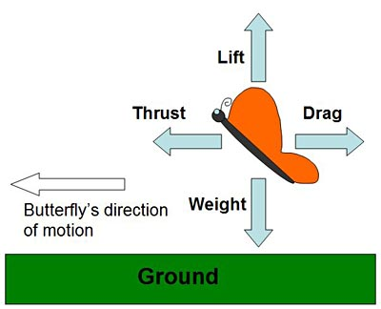
Figure 2. The butterfly in this diagram is moving to the left. Lift on the wings must support the butterfly's weight to keep it in the air. Thrust pushing the butterfly forward must overcome drag, which slows it down.
As you can probably imagine, it is very difficult to take measurements of real butterflies that are flying around! Instead, the scientists used artificial butterfly wings they made in a laboratory. They put those wings in a wind tunnel, which is a scientific instrument that lets scientists very accurately control the speed and smoothness of air flow. To simulate gliding (as opposed to flapping), the wings were held in a fixed position. The artificial butterfly wings were connected to a force sensor, which let them measure lift and drag in a carefully controlled environment so they could directly compare different butterfly species' wings. Imagine how hard it would be to do that outside on a gusty, windy day! Figure 3 shows a diagram of a typical wind tunnel. It consists of a fan that sucks air into a tunnel, where it flows past the butterfly wing in a test section before exiting through the tunnel's exhaust. For this experiment your wind tunnel will be much simple, just a fan, a kitchen scale, and a stand you make from popsicle sticks.
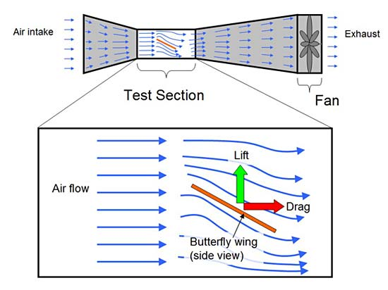
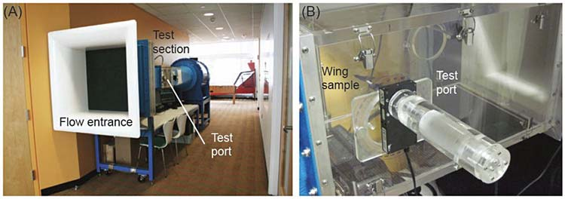
Figure 3. The top image shows a side-view diagram of a typical wind tunnel with a zoomed-in view of the test section, which contains the butterfly wing. A very powerful fan (much bigger than the window fan you will use in this experiment) sucks air through the tunnel. One end of the tunnel is a large opening, which gets narrower, causing the air to speed up (it works just like the nozzle on a garden hose, but with air instead of water). The air that enters the test is moving in very straight, smooth lines when it hits the butterfly wing, which is attached to a force sensor (not shown in the diagram). This allows the scientists to make controlled, accurate measurements of lift and drag. Finally, the air flows past the butterfly wing and out the "exhaust" end of the tunnel. The bottom image shows a picture of the actual wind tunnel used in the Harvard experiment—(A) the whole tunnel and (B) the test section (Harvard Microrobotics Lab, 2012).
In the Harvard study, one thing the scientists tested was the effect of angle of attack on how much lift is generated. Angle of attack is the angle between a wing (when viewed from the side) and the direction of the wind in the wind tunnel, as shown in Figure 4. Angle of attack is usually represented by the lowercase Greek letter α.
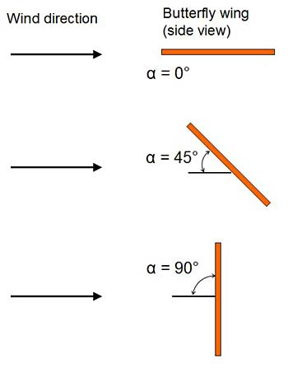
Figure 4. Angle of attack is the angle between the wing (when viewed from the side) and the direction of the wind. This diagram shows angles of attack of 0°, 45°, and 90°.
Changing the angle of attack can have a big impact on lift. More lift can make flying easier and require less energy. Looking at Figure 4, which angle of attack (0°, 45°, or 90°) do you think would generate the most lift for a butterfly? In this science project, you will do an experiment to measure how changing angle of attack changes the lift force on paper butterfly wings. The version of the experiment you can do at home is very simple compared to the real (and quite expensive) wind tunnel that the Harvard researchers used, but it will still allow you to investigate some fundamental principles of butterfly flight.

Terms and Concepts
- Glide
- Aerodynamics
- Lift
- Force
- Weight
- Drag
- Thrust
- Wind tunnel
- Force sensor
- Angle of attack

Questions
- What are the four forces that act on a flying object? Which ones cancel each other out?
- What do scientists use wind tunnels for?
- How do you think changing angle of attack changes lift and drag?
- Have you ever held your hand out the window of a moving car, or in front of a strong fan? How does rotating your hand affect the lift force that you feel (pretend your hand is a wing)?
- What angle of attack do you think real butterflies use when they glide during flight?

Bibliography
- Kovac, M. (2011, February 21). Monarch butterfly flapping and gliding in slow motion (240 fps). Retrieved August 13th, 2013, fromhttp://youtu.be/_SbihKIoOPU.
- Smithsonian Institution. (n.d.). Butterflies. Retrieved August 13, 2013, from http://www.si.edu/Encyclopedia_SI/nmnh/buginfo/butterfly.htm.
- Kovac, M., et. al. (2012, October 7). Aerodynamic evaluation of four butterfly species for the design of flapping-gliding robotic insects. IEEE/RSJ International Conference on Intelligent Robots and Systems. Retrieved August 13, 2013, from http://micro.seas.harvard.edu/papers/IROS2012_Kovac.pdf.
- Harvard Microrobotics Lab. (n.d.). Welcome to the Harvard Microrobotics Lab. Retrieved August 29, 2013, from http://micro.seas.harvard.edu/.
- NASA. (n.d.). Four Forces on an Airplane. Retrieved August 13, 2013, from http://www.grc.nasa.gov/WWW/K-12/airplane/forces.html.
For help creating graphs, try this website:
- National Center for Education Statistics, (n.d.). Create a Graph. Retrieved June 2, 2009, from http://nces.ed.gov/nceskids/createagraph/

Materials and Equipment
- Computer with internet access, and that is connected to a printer
- 8.5 inch (in.) x 11 inch cardstock (1 sheet)
  - Note: If your printer cannot print directly onto cardstock, you will need 8.5 inch x 11 inch printer paper (1 sheet) and a pencil or pen for tracing.
- Scissors
- Wooden craft sticks (80)
- Tape, to attach the craft sticks to paper
- Wood or craft glue (or could also use tape)
- Protractor
- Small binder clips (2)
- Large window or box fan
- Kitchen scale with 0.1 gram (g) resolution. A kitchen scale can be purchased locally or at Amazon.com.
- Several heavy object(s) to act as weights that will keep your craft stick supports and cardstock butterfly wings from blowing off the scale, such as cell phones, wallets, rolls of masking or electrical tape, etc.

Experimental Procedure

Building Your Paper Butterfly
- Make a hypothesis about what butterfly wing angle of attack you think will generate the most lift during gliding.
  - If possible, it may help to observe real butterflies, either outside or at a butterfly house (which your city may have). If you have a video camera, you can make your own recordings of the butterflies in flight so you can go back and re-watch them.
  - If you cannot observe real butterflies, you can re-watch the video from the Introduction, and search online for additional videos of butterflies in flight.
  - Can you clearly see times when the butterflies glide, without flapping their wings? Can you guess the angle of attack during gliding?
- Download the file butterfly-outlines.pdf . This is a four-page PDF file with wing outlines for the four different species used in the Harvard study: the Monarch, Glasswing, Fourbar Swordtail, and Orange Aeroplane (Figure 5). Pick your favorite butterfly from Figure 5 to work with.
  - Fun fact: The wind tunnel you build in this project is too simple to detect the small differences in lift between different styles of butterfly wings — but the Harvard study had sensitive enough equipment to discover that Glasswing and Monarch wings are better than Fourbar and Swordtail wings when it comes to gliding.
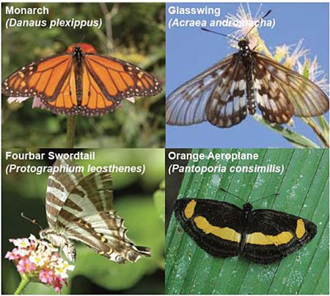
Figure 5. The four different butterfly species tested in the Harvard study (Harvard Microrobotics Lab, 2012).
- Once you have picked your favorite butterfly from Figure 5, print the appropriate page from butterfly-outlines.pdf onto an 8.5-in. x 11-in. piece of cardstock. Be sure to print the page in "landscape" orientation.
  - If your printer cannot print directly onto cardstock (it is thicker than regular printer paper), print the design onto a piece of normal printer paper. You will trace it onto cardstock later.
  - Figure 6 shows what the four species should look like when printed (remember to only pick one).
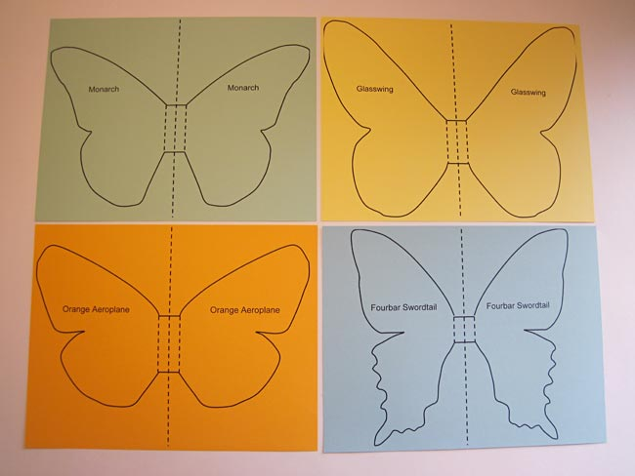
Figure 6. Printouts of the four different butterfly species. You will only need to print out one for this science project.
- Carefully cut out the outline of your butterfly, as shown in Figure 7.
  - If you printed your design on regular printer paper, cut it out, then trace the outline onto a piece of cardstock, and cut out a cardstock copy.
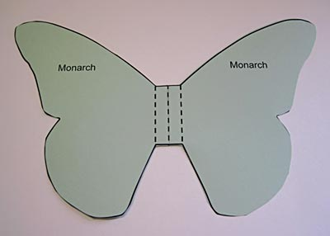
Figure 7. Cutout of a Monarch butterfly. Remember that you do not have to use the Monarch; you can pick your favorite butterfly from Figures 5 and 6.
- Fold the middle of your cutout butterfly to make it like a paper airplane, as shown in Figure 8.
  - Fold the butterfly in half along the middle dashed line.
  - Fold the wings down along the other two dashed lines, in the opposite direction of your first fold.
  - Unfold the wings. The middle part of the butterfly should now form a "V" shape, which you will use to clip on to your test stand later.
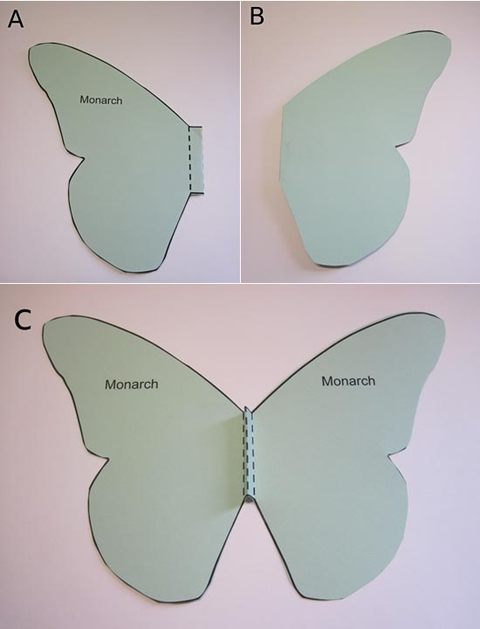
Figure 8. Follow the instructions in steps 5.a.–5.c. to fold your paper butterfly along the dashed lines.
- Tape a craft stick onto the back of your butterfly, as shown in Figure 9. This will prevent the wings from folding back when you test it in your wind tunnel.
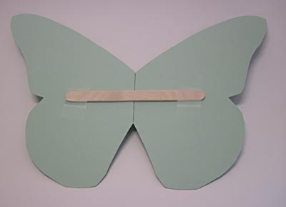
Figure 9. A craft stick taped to the back of the butterfly will prevent the wings from folding closed during testing.

Building Your Support Structures
This section will walk you through building "support structures" out of wooden craft sticks. Each support structure will be built to help you test a specific angle of attack, so you will build ten total (0°–90° in 10° increments). Figure 10 shows several example support structures.
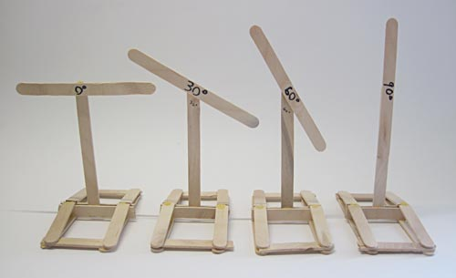
Figure 10. Some examples of finished support structures for different angles of attack.
- Create an angle guide.
  - Use a protractor and a blank piece of paper to create a guide with angles marked from 0°–90°, in 10° increments, as shown in Figure 11.
  - Start out by drawing a horizontal line.
  - Next, draw a vertical line at a 90° angle to the horizontal line. Ask an adult for help if you do not know how to use a protractor to do this.
  - Finally, draw lines in 10° increments between your horizontal line and the vertical line, as shown in Figure 11. Label the lines for easy reference later.
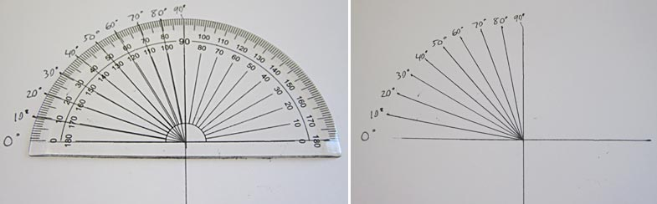
Figure 11. The angle guide you will use to create supports with certain angles of attack.
- The procedure will walk you through building one example support structure (30°) so you understand how to use the angle guide. You will repeat these steps to build the remaining support structures.
  - Using your angle guide, line up the right edge of one craft stick with the vertical line, and the top edge of another craft stick with the 30° line, as shown in Figure 12.
  - Use a small amount of glue to glue the sticks together. Make sure you re-align the craft sticks with the appropriate lines if you move them to apply glue.
  - Be sure to let the glue dry completely before you continue.
  - Use a permanent marker to label the angle so you do not get your different support structures mixed up later.
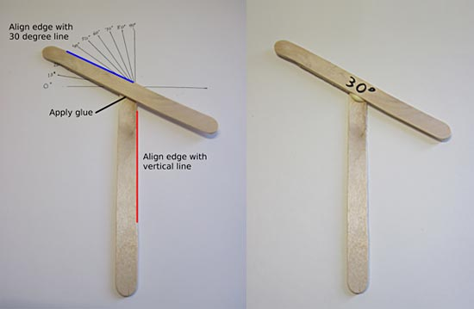
Figure 12. Use the angle guide you created in step 1 to measure the angle of attack for each one of your supports.
- Cut or break one craft stick in half, and glue the pieces onto the bottom of both sides of your vertical stick, as shown in Figure 13. Remember to let the glue dry completely before moving to step 4.
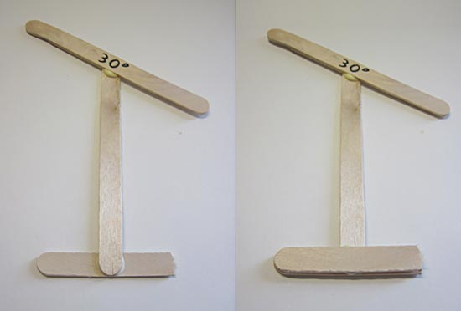
Figure 13. Glue two half-sticks to the bottom of your vertical stick, as shown here.
- Use three craft sticks, one of which is cut in half (leaving you with four pieces total), to glue together a rectangular base, as shown in Figure 14.
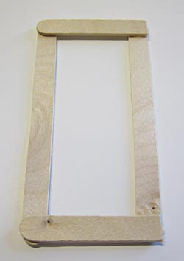
Figure 14. The rectangular base for the support structure.
- Glue the top part of the support structure onto the rectangular base, as shown in Figure 15. You will need to hold it in place until the glue solidifies.
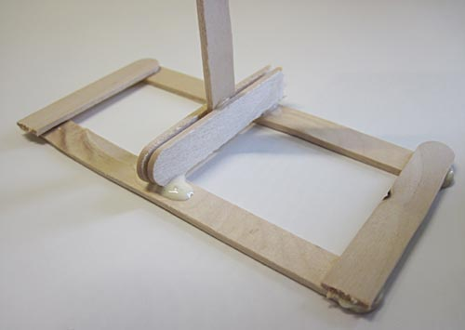
Figure 15. Glue the top half of the support structure onto the base.
- Cut two craft sticks in half and glue them on as additional support braces to help keep the top half of the structure upright, as shown in Figure 16.
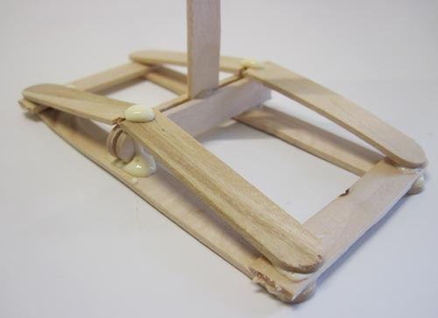
Figure 16. Cut two craft sticks in half and use them to secure the top half so it does not fall over.
- Figure 17 shows the finished 30° support structure. Repeat steps 2–6 of this section to build the eight remaining support structures (0, 10, 20, 40, 50, 60, 70, 80, and 90 degrees).
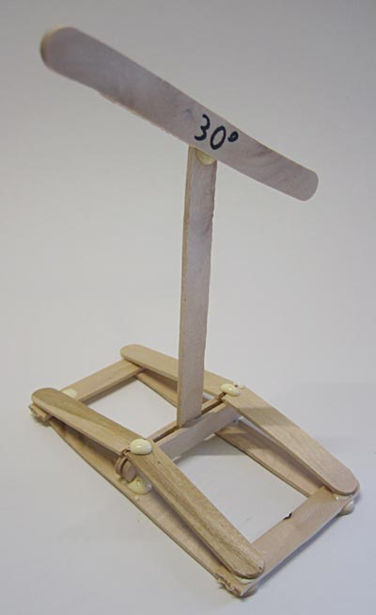
Figure 17. Completed 30° support structure.

Doing the Experiment
- Make a data table like Table 1 in your lab notebook.
Lift (grams [g])
Angle of Attack (deg) | Trial 1 | Trial 2 | Trial 3 | Average
0
10
20
30
40
50
60
70
80
90
Table 1. Data table for recording lift measurements at different angles of attack.
- Clip your butterfly onto your 0° support structure using two binder clips, as shown in Figure 18.
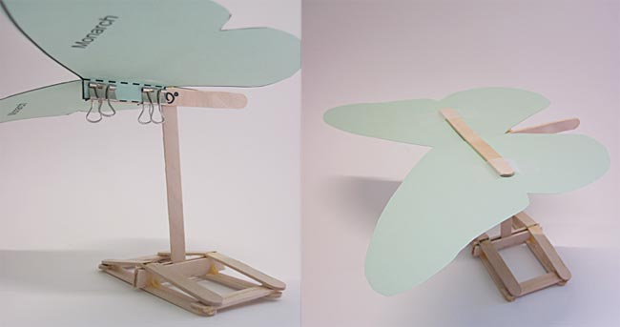
Figure 18. A butterfly attached to the support structure with binder clips.
- Place your scale and your fan approximately 1 meter (m) away from each other on a hard, flat surface.
  - Try to set up your experiment as far away from any walls or other obstructions (like furniture) as possible.
  - Try to avoid other sources of air flow, like ceiling fans or open windows.
  - The exact distance between your scale and your fan will depend on the size of your fan. You want your scale to be in a region of smooth, even air flow. Use your hand to feel the breeze flowing from the fan, and try your best to place the scale in a location where you feel strong, consistent air flow.
- Place your support structure, with a butterfly clipped on, on top of the scale with the butterfly facing toward the fan, as shown in Figure 19.
  - Use one or two heavy objects to weigh down the bottom of the support structure. Figure 20 shows two rolls of electrical tape used for this purpose.
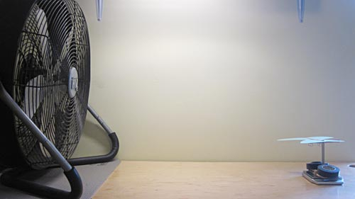
Figure 19. The homemade "wind tunnel" setup with a fan, scale, and support structure (held down by two rolls of electrical tape) to hold the test butterfly wings.

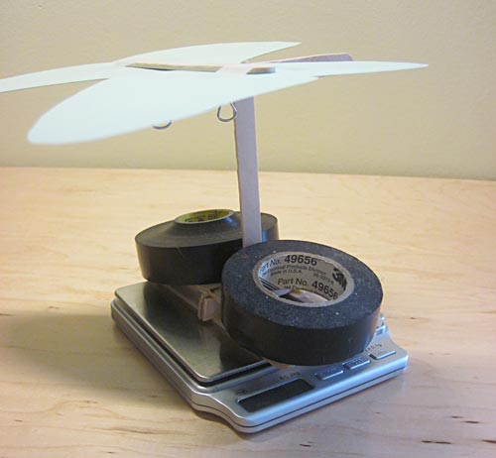
Figure 20. Use heavy objects, like a wallet, cell phone or rolls of tape, to prevent the support structure and butterfly from blowing away.
- Press the "tare" button on the scale. This makes the scale re-zero itself so it does not include the weight of the support structure in its measurement.
  - Important: Starting with this step, be as careful as you can not to move the scale. Moving the scale to an area where air is flowing at a different speed will affect your results. If possible, you should mark the location of the scale (for example, using a piece of removable tape on the hard surface); that way, if you do accidentally bump or move the scale, you can return it to its original location.
- Turn on the fan. If your fan has multiple speeds, start at the lowest speed (see the Make It Your Own tab for ideas about testing different speeds).
- Observe the value on the digital scale's display. Remember that the value should be negative since the butterfly is being lifted up, off the scale (instead of pressing down on it). If your scale does not display negative values, see step 7.b.
  - Because you are using a very rough homemade wind tunnel, the scale's measurement may bounce around a bit. Try your best to record an averagevalue in the data table in your lab notebook. For example, if the reading oscillates between 8.0 g and 10.0 g, you would write down 9.0 g (you can ignore the minus sign).
  - Note that some kitchen scales may not display negative values. If this is the case with your scale:
    - Remove the butterfly, support structure, and weights from the scale.
    - Tare the scale (make sure it reads zero).
    - Place the butterfly, support structure, and weights back on the scale. Record the reading on the scale while the fan is off.
    - Turn on the fan, and record the reading on the scale while the fan is on. As described, this value may bounce around; do your best to record an average value.
    - Subtract these two values to determine the lift. For example, if you measured 20 g while the fan was off, and 15 g while the fan was on, your lift measurement is 20 - 15 = 5 g.
- Turn off the fan and wait for it to come to a complete stop. If the scale's value has drifted away from zero, press the "tare" button again.
- Repeat steps 6–8 two more times, for a total of three trials for first angle of attack.
  - Be sure to record the results in your data table.
  - After you have completed three trials, calculate an average lift value and enter it in your data table. Ask an adult for help if you do not know how to calculate an average.
- Repeat steps 4–9 for each remaining angle of attack. Remember to be careful not to bump or move the scale.
- Analyze your results.
  - Make a plot of average lift vs. angle of attack, with angle of attack on the x-axis and lift on the y-axis. If you need help making a plot, you can use the Create a Graph website.
  - What does the shape of your graph indicate? What angle of attack has the most lift? What angle, or angles, of attack have the least lift? Do your results make sense to you?
  - Is this consistent with your predictions? How do you think this is similar to or different from how real butterflies fly?
  - Remember that real butterflies (and the Harvard experiment) also have to consider drag and not just lift. Do you think this could explain any differences between your results and real butterflies?

References
Science Buddies Staff. "Butterfly Wings: Using Nature to Learn About Flight." Science Buddies, 23 June 2020, https://www.sciencebuddies.org/science-fair-projects/project-ideas/Aero_p049/aerodynamics-hydrodynamics/butterfly-wings-using-nature-to-learn-about-flight. Accessed 10 Dec. 2020. https://www.sciencebuddies.org/science-fair-projects/project-ideas/Aero_p049/aerodynamics-hydrodynamics/butterfly-wings-using-nature-to-learn-about-flight#procedure

