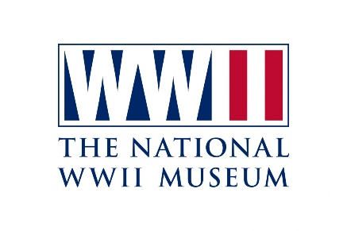
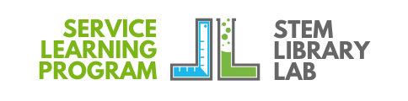
2022-2023 The National WWII Museum Complimentary Group Reservation Request
Offer valid October 3, 2022 - May 31, 2023 for Service Learning awardee groups underwritten by STEM Library Lab and the Joe W. and Dorothy Dorsett Brown Foundation.
Please print clearly using black ink on the reservation form. Scan and email the request to Maria Landrum at maria@stemlibrarylab.org.

School Name: _________________________________________ Parish: ____________________________
Address: ________________________________________ City/State/Zip: ____________________________
Group Leader’s Name: _____________________________________ Primary Phone: ___________________
Cell Phone: ( ) _____________________ Email Address: _____________________________________
The National WWII Museum is open seven days a week from 9:00 AM - 5:00 PM.
Schools seeing the Beyond All Boundaries 4-D Movie must check in 30 min. before the film starts.
The USS Tang Submarine Final Mission Experience is booked hourly starting at 9:35 a.m., and at 15, 35, 55.
Movie times are every hour on the hour from 10:00 AM - 4:00 PM.
March - May film will begin at 9:00 AM for student groups.
The most popular times are 10:00 AM and 11:00 AM, so please book early for these times.

Write in 2 preferred dates. At least 2 weeks is needed to process your reservation request.
The National WWII Museum’s Group Sales Department will contact you to confirm your visit
Average visit: 2 hours for the galleries, 1 hour for the film, and 30 minutes for the USS Tang Experience.

Circle only 1 of these 4 choices:
1) Museum only. 2) Museum and Movie. 3) Museum and USS Tang. 4) Museum, USS Tang, & Movie.

1. Preferred Day/Date: _______________ Arrival time: _________ Movie time: _________ USS Tang time: _________
2. Preferred Day/Date: _______________ Arrival time: _________ Movie time: _________ USS Tang time: _________

Grade Level(s): ________ # of Students:_______ # of Adults: ______ # of Busses: _______

*Face masks are required. A ratio of 1 adult per 10 students is required. Confirmation from The National WWII Museum concerning instructions, assigned date/time to be sent.

Office Use - STEM Library Lab Approval Signature

Signature: ______________________________________________________ Date: _____________________

